Diffusion

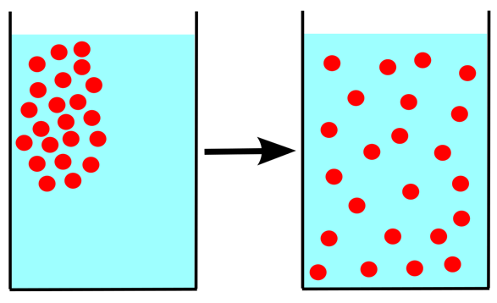Diffusion: when __________________ spread out from an area with ___________ of particles to an area with ___________or no particles.

Diffusion **only works in ___________________________ that allow particles to ____________________.** If particles can’t move, they can’t spread out, and diffusion can’t happen.

Remember, all matter is ________________, but not all states allow particles to **move around** each other.

**Will it diffuse?**

* Predicting and explaining diffusion is a simple process:
  1. Identify the state/s of matter (solid / liquid / gas)
  2. Describe the movement of the particles in the substances
  3. Use your description to explain why diffusion will / won’t happen

Questions:

In which states of matter can diffusion occur?  
_______________________________________________________________________________________

Decide if diffusion is occurring in the following situations. Explain your answer.

1. You pour cordial into your glass of water.  
   __________________________________________________________________________________________________________________________________________________________________
2. You spill sugar on the table.   
   __________________________________________________________________________________________________________________________________________________________________
3. You spray perfume and someone on the other side of the room can smell it.   
   __________________________________________________________________________________________________________________________________________________________________

The following diagram represents a teabag in a hot cup of water. In the other glasses, draw the particles to demonstrate what happens to the tea as it diffuses throughout the water.

